- INTRODUCTION

Improved Prim Algorithm and Its Application in Unmanned Aerial Vehicle Cruise System
Funa Zhou¹, Po Hu^{1,*}, Xiaoliang Feng² ,Yansui Song³
1. School of Computer and Information Engineering, Henan University, Kaifeng, China
E-mail: zhoufn2002@163.com, hupo4210@163.com (* Corresponding Author)
2. College of Electrical Engineering, Henan University of Technology, Zhengzhou, China
E-mail:fengxl2002@163.com
3. College of Automation, Northwestern Polytechnic University, Xian, China
E-mail: yansuisong8086@163.com
Abstract: Unmanned Aerial Vehicle (UAV) can perform tasks such as military reconnaissance, monitoring, search and target pointing. When a UAV is used to perform a reconnaissance task on a cruise path planning, and certain set of multi-target point, the optimal cruise path should be well scheduled to ensure that the cruise time is minimal. In this paper, an improved Prim algorithm is studied by introducing constraint condition to improve the effect of UAV path planning. Based on the data provided by GPS module, the weight matrix between the target points is obtained by using coordinate transformation, and the optimal cruise sequence is obtained by using the improved Prim algorithm. Simulation results and success application in cruise path planning of UAV show the efficiency of this improve Prim algorithm.
Key Words: UAV; path planning; Prim algorithm; coordinate transformation

The recent decade has witnessed the growing concern on unmanned aerial vehicle (UAV), which has been applied in more and more application fields. An important application of UAVs is to implement the reconnaissance mission in forest fire protection, public safety, or such other fields. A good cruise path can not only reduce the cost of executing the reconnaissance task, but also reduce its risk. The cruise path for UAV is usually planned by the methods of static planning or dynamic planning. Static planning refers to the cruise path has been planned before the aircraft took off, and dynamic programming is the process of cruising in accordance with the need to dynamically modify the course of the path planning [1, 2]. Dynamic programming is based on static programming, so static programming is one of the main contents of this paper.
For the problem of path planning, A-Star search algorithm [3], genetic algorithm [4], dynamic programming [5], Dijkstra algorithm [6], particle swarm algorithm [7] and so on are commonly used. The A-Star algorithm determines the next path grid by comparing the heuristic function values F of eight neighbors of the current path grid. However, the A-Star algorithm can’t guarantee the optimal path when there are multiple minimum values. In the case of improper selection of fitness function, genetic algorithm may converge to local optimum, but can’t achieve global optimization. In this paper, the UAV path optimization algorithm is based on the Prim algorithm. The minimum spanning tree (MST) constructed by connecting vertexes one by one, it can solve the optimal path problem [8, 9]. In this paper, an improved Prim algorithm is proposed for the path optimization problem, which has the same time complexity with Prim algorithm, but easier to understand and achieve, the most important thing is its effect is much better than the original algorithm. Through the validation of a large number of experimental data, the solution obtained by the proposed algorithm is same as the global solution obtained by traversing all the possible solutions. In practice, the target coordinates data is usually showed by latitude and longitude of Geodetic Coordinate System, which is also the most common and easiest to get. For the cruise path planning system of UAVs, the system input data for each specified point is the data in the Geodetic Coordinate System coordinates, the data of each coordinate point must be converted into the Spatial Cartesian Coordinate system [10]. The significance of coordinate transformation is that the actual distance between any two points can be directly calculated from the Spatial Cartesian Coordinate system, which is foundation for the path planning problem.
The aircraft flight control is based on the integral separation PID algorithm [11, 12]. The accelerometer and the three-axis gyro sensors are used to obtain the acceleration and rotation angular velocity of the vehicle. The elevation angle pitch, roll angle roll and yaw angle yaw are obtained by 3D attitude calculation [13]. The three attitude variables are used as the control variables of the

PID algorithm and the result is output to the actuator of the aircraft, so as to realize the balance control of the aircraft. With the GPS module, the aircraft's own coordinates can be obtained [14], and the aircraft can be controlled by the PID algorithm, which can cruise the target point according to the cruise order after the path planning, finally, the UAV can autonomously plan paths and perform reconnaissance tasks.
- PRIM ALGORITHM
Prim's algorithm is an algorithm to construct the minimum spanning tree of a graph [15-17]. It constructs the minimum spanning tree by connecting vertexes one by one. Primer's basic idea is described as follows:
Starting from a vertex in the connected graph G = (V, {E}), the minimum weight edge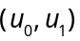 associated with it is selected and its vertices are added to the vertex set U of the spanning tree. Each step is then selected from the edges (u, v) whose vertices are in U and the other vertices are not in U, and the edges are added to the edge set TE of the minimum spanning tree, the other vertices are added to the set U. This is repeated until all the vertices in the network are added to the vertex set U of the spanning tree.
For the undirected connected weighted graph G = (V, {E}) with n vertices, in the resulting spanning tree with n-1 edges and vertices connected to each other, And the smallest tree process, that is, the process of constructing the minimum spanning tree. The process of constructing the minimum spanning tree using Prim algorithm is shown in Fig.1. V1toV6 are the target points, and the number between the two target points is the weight between the two target points. An undirected weighted connected network G is shown in Fig.1. (a). Fig.1. (b)- (f) are to construct the minimum spanning tree. From all the nodes in the network, any one of them can be taken as the starting point. Without loss of generality, take V1 as the starting point. Find the smallest weight value from all the edges connected V1 with other points in Fig.1. (a), and connect the two points as shown in Fig.1. (b). Then find the points with the smallest weight among all the points adjacent to these two points, connect them, as shown in Fig.1. (c).Along this way, until the formation of n-1 sides, the spanning tree is constructed as shown in Fig.1. (f).
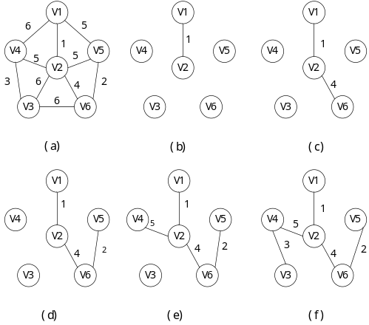
Fig.1. Process of Construct the Minimum Spanning Tree by Prim Algorithm.
The process of constructing the minimum spanning tree using Prim algorithm is shown in Fig.1. A more specific description of the steps to construct the minimum spanning tree is as follows.
Step1: Initialize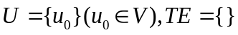.
Step2: From the constructed edges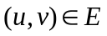 constituted by any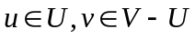, find an edge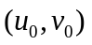 with the least weight value, then add it to, and take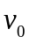 in.
Step3: If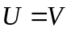, then turn Step4, otherwise go to Step2.
Step4: Therefore, in the spanning tree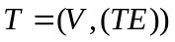, there must be an edge-set including 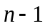edges, is the minimum spanning tree of the connected graph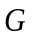.
- IMPROVED PRIM ALGORITHM
Prim's algorithm is an algorithm to construct the minimum spanning tree of a graph [15-17]. It constructs the minimum spanning tree by connecting vertexes one by one. Primer's basic idea is described as follows:
In this sub-section, the Prim algorithm is improved to solve the problem of UAV path planning. There are two aspects that need to be improved. First, from the Prim algorithm described above, the uncertainty of the initial point selection will result in that the spanning tree search using Prim algorithm is not unique. In practice, we want to get the spanning tree which is the only optimal. Therefore, Prim algorithm must be improved by setting the necessary search starting point, the search limit conditions and search order, to make the original uncertainty of the process into a certain process, and retain the advantages of Prim algorithm in the same time. Second, although the minimum spanning tree path can be used directly to construct the UAV cruise path, but in reality we hope that the UAV cruise path is a non-reciprocating path. However, the minimum spanning tree will inevitably lead to some side of the vertex degree more than 2, which will form a reciprocating path and an increase of cruising costs. In view of these two aspects of the improvement requirements, the improved algorithm is described as follows.
Step1: Traverse all edges, and find the edge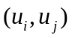 with the smallest weight, add the vertex 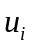and 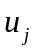into the set of vertices , 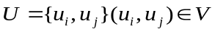，the set of edge
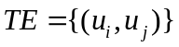.
Step2: Taking the vertex and in the set 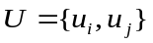 as the search starting point, and the minimum spanning tree T is obtained by the Prim algorithm.
Step3: If there is any vertex degree of the minimum spanning tree T is greater than 2, deletes all edges connected to the vertex except for the two edges with the smallest weight values. Otherwise, directly turn to Step4.
Step4: Find an edge that is connected by vertices with degrees less than 2, and is the least weighted, before adding this edge to the set, check whether the loop is formed. If a loop is generated, the edge is discarded. Then continue find the next smaller edge. Otherwise perform the fifth step.
Step5: Add the edge to the set TE. If the number of edges is less than n-1 (where n is the number of vertices), proceed to step 4. If the number of edges is equal to n-1, the shortest path planning is completed.
The following 10 target points are an example to illustrate the effectiveness of improved Prim algorithm, the coordinates of the target point in the Cartesian coordinate system is shown in Table 1.
The weight matrix between any two target points, also distance matrix between the target points, is calculated from the ten points shown in Table 1, as shown in Table 2.
Those coordinate data of ten target points in Table 1 and the distance matrix data between two target points in Table 2 as an example, the steps to get the optimal solution using improved Prim algorithm are described as follows.
Step 1: Initialize: Traverse all edges, and find the edge with the smallest weight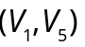, these two points are added to the set. 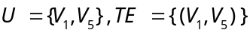.
Step 2: Taking the set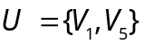as the starting point, use Prim algorithm, get the minimum spanning tree T, as shown in Fig. 2. (a).
Now
Step 3: It is easy to see from Fig. 2. (a), only verticesandhave degrees greater than 2，and the edge with the largest weight in the edge connected to vertex is edge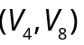, so delete the edge , similarly, delete the edge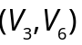.
Now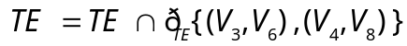.The results are shown in Fig. 2. (b).Then create a new set which contains all the vertices with degrees less than 2,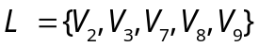
Step 4: In set, any two points are connected to form an edge set, find the edges with the smallest weight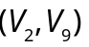 in edge set. Add to the set, since there is no loop, so the edge is added to the, otherwise, discard the edge, as shown in Fig.2. (c). Now,, then continue proceed to step 4, find the smallest weight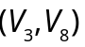, add it to the edge set, since there is no loop, and the number of edges is equal to n-1 . So the path planning is completed. The optimal path is shown in Fig. 2 (d). That is, the optimal path is and the total length of the scheduled path is 234.68.

Table 1 Coordinate of Target Point

Point
Coordinate | (42,83) | (85,104) | (96,78) | (73,47) | (52,72)
Point
Coordinate | (69,70) | (40,23) | (105,38) | (55,103) | (70,21)

Table 2 Weight Matrix between Target Points

 | 0.00 | 47.85 | 54.23 | 47.51 | 14.87 | 29.97 | 60.03 | 77.42 | 23.85 | 68.03
 | 47.85 | 0.00 | 28.23 | 58.25 | 45.97 | 37.58 | 92.66 | 68.96 | 30.02 | 84.34
 | 54.23 | 28.23 | 0.00 | 38.60 | 44.41 | 28.16 | 78.49 | 41.00 | 48.02 | 62.65
 | 47.51 | 58.25 | 38.60 | 0.00 | 32.65 | 23.35 | 40.80 | 33.24 | 58.82 | 26.17
 | 14.87 | 45.97 | 44.41 | 32.65 | 0.00 | 17.12 | 50.45 | 62.97 | 31.14 | 54.08
 | 29.97 | 37.58 | 28.16 | 23.35 | 17.12 | 0.00 | 55.23 | 48.17 | 35.85 | 49.01
 | 60.03 | 92.66 | 78.49 | 40.80 | 50.45 | 55.23 | 0.00 | 66.71 | 81.39 | 30.07
 | 77.42 | 68.96 | 41.00 | 33.24 | 62.97 | 48.17 | 66.71 | 0.00 | 82.01 | 38.91
 | 23.85 | 30.02 | 48.02 | 58.82 | 31.14 | 35.85 | 81.39 | 82.01 | 0.00 | 83.36
 | 68.03 | 84.34 | 62.65 | 26.17 | 54.08 | 49.01 | 30.07 | 38.91 | 83.36 | 0.00

To verify the validity of the algorithm, by traverse all solutions, the global optimal solution is 234.68. The results show that the improved Prim algorithm is globally optimal.
- APPLICATION OF IMPROVED PRIM IN UAV PATH PLANING
  - UAV Experimental Platform Description
In this paper, the experimental platform is four-rotor aircraft [18]. The main controller chip for this experimental
Platform is STM32f104. The experimental platform contains wireless data transmission module, motor drive circuit, GPS, and so on. In the four-rotor control panel, OLED is used as human-computer interaction interface, the control panel through the NRF24L01 wireless module to enter data to the host Microcontroller Unit (MCU). Brushless motor used as actuator, the test module is used to test whether the aircraft arrived at the designated location. The experimental platform is shown in Fig.3.

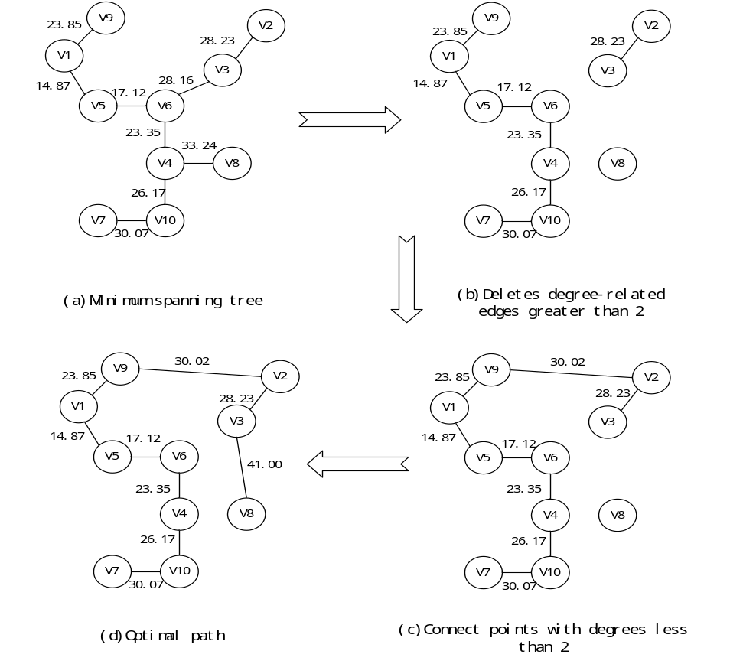
Fig.2. Implementation Process of Improved Prim Algorithm

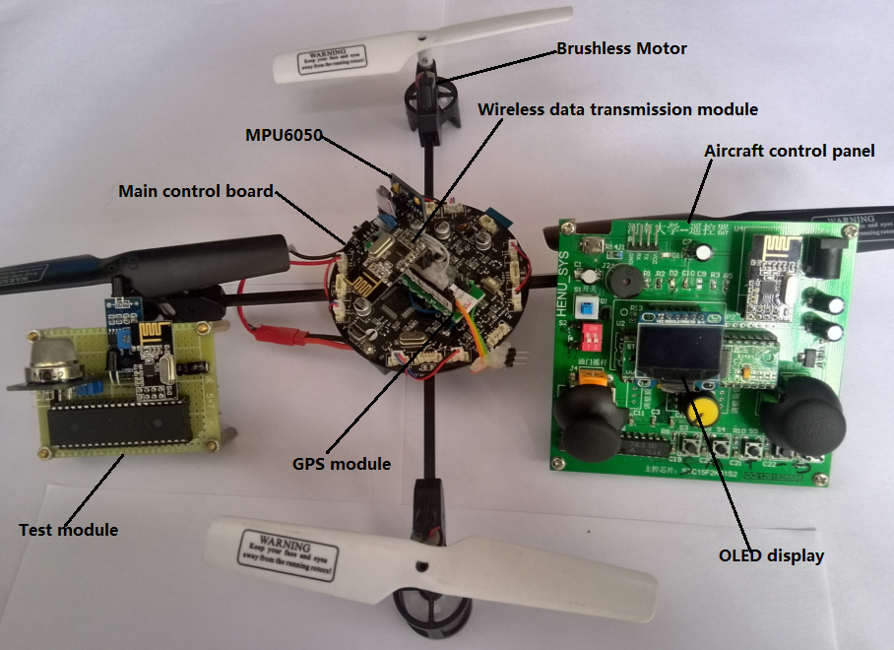
Fig.3. Experimental Platform

Coordinate data in the geodetic coordinate system of the Specified target point is input to the main MCU before the cruise of the unmanned aerial vehicle. First, the coordinates in the geodetic coordinate system are transformed into the coordinates in Spatial Cartesian Coordinate system. Then the coordinate of all target points is input to the improved Prim algorithm, and the optimal path of UAV cruise is the output as the result of the algorithm. Finally, the UAV in accordance with the planned path, perform reconnaissance missions.
The algorithm given in Section 3 of this paper is descripted in Cartesian coordinate system. Figure 4 is the system framework of the experimental platform we developed based on the hardware frame illustrated in Figure 3. PID controller is used for attitude stabilization control of UAV [19]. Additional GPS module is equipped on the UAV to obtain the coordinates of the aircraft itself. Taking the improved Prim algorithm for unmanned aerial cruise, it is necessary to convert the geodetic coordinate system to spatial Cartesian coordinate system.

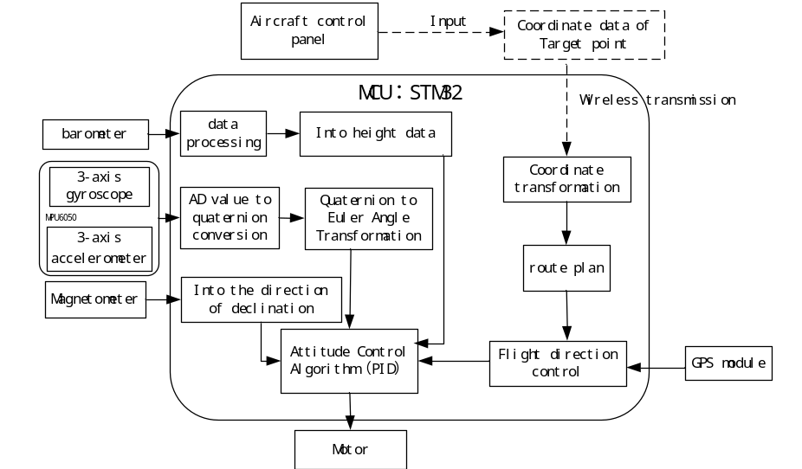
Fig.4.Framework for the Aircraft

  - Coordinate System Transformation
For each target point that needs to be cruised, it is very convenient to get the coordinate data in longitude and latitude. Since the path planning algorithm is developed in Spatial Cartesian coordinate system, it is necessary to transform the original data obtained in geodetic coordinate system to Spatial Cartesian coordinate system.
The origin of Spatial Cartesian coordinate system lies in the center of the reference ellipsoid. The Z axis points to the north pole of the reference ellipsoid. The X axis points to the intersection of the starting meridian and the equator. And the Y axis lies on the equatorial plane. According to the right-handed coordinate system, the angle between X and Y axis is 90°.The coordinate of a point in space can be represented by the projection on each coordinate axis of the coordinate system. The Spatial Cartesian coordinate system can be represented by Fig.5.

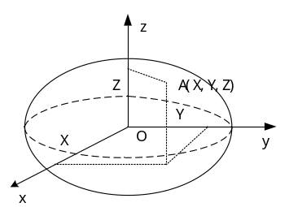
Fig.5. Spatial Cartesian coordinate system

In Geodetic Coordinate System, latitude, longitude and surface height are used to describe the spatial location. Geodetic Coordinate System can be shown in Fig. 6.

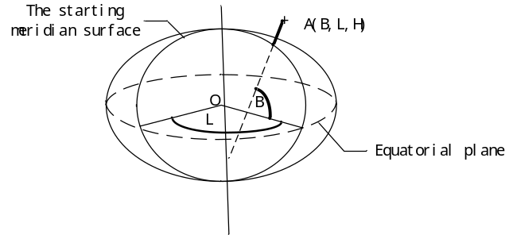
Fig.6. Geodetic Coordinate System

The coordinate transformation process can be described in Eq. (1)
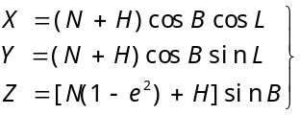 (1)
Where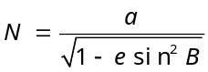, 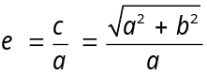.is the curvature radius of ellipsoid, is the eccentricity, is the long axis of the ellipsoid, is the short axis of ellipsoid. According to the national geodetic coordinate system criterion of 2000, the value of these parameters is listed in Table 3.

Table 3 Value of the Parameter
parameter | value
 | 6378.137km
 | 6356.7523141km
 | 0.081819191042811
Taking Henan University as an example, eleven target points are selected in Henan University. Assume that ground height of the target point is zero. By the above formula, the coordinates of Geodetic Coordinate System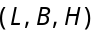 of each target point and the corresponding coordinates of the Spatial Cartesian coordinate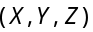 system are obtained. The coordinate transformation results of which are shown in Table 4.
Table 4 Coordinate Conversion Results
 | longitude | latitude | X | Y | Z
A | 114.3194 | 34.8249 | -2185.59 | 4836.17 | 3667.23
B | 114.3191 | 34.8253 | -2185.55 | 4836.15 | 3667.28
C | 114.3191 | 34.8257 | -2185.54 | 4836.13 | 3667.31
D | 114.3193 | 34.8270 | -2185.52 | 4836.05 | 3667.43
E | 114.3198 | 34.8277 | -2185.55 | 4835.99 | 3667.50
F | 114.3169 | 34.8274 | -2185.31 | 4836.12 | 3667.47
G | 114.3177 | 34.8259 | -2185.41 | 4836.17 | 3667.33
H | 114.3163 | 34.8246 | -2185.33 | 4836.30 | 3667.21
I | 114.3157 | 34.8246 | -2185.28 | 4836.32 | 3667.21
J | 114.3155 | 34.8236 | -2185.29 | 4836.38 | 3667.11
K | 114.3168 | 34.8230 | -2185.41 | 4836.37 | 3667.06
Where A denoted Zhi Yi Stadium, B denoted Educational Science College, C denoted Teaching Building No. 7, D denoted Bei Yuan Restaurant, E denoted college of Life Sciences, F denoted Special Functional Materials Laboratory, G denoted College of Economics, H denoted Software College, I denoted School of Computer and Information Engineering, J denoted Xia Chen square, K denoted Teaching Building No. 1 .The distance between two target points can be calculated by Eq. (2)
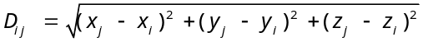 (2)
The weight matrix between the target points can be obtained from Table 4 and Eq. (2). The element values in the weight matrix represent the distance values between the target points. From the latitude and longitude data calculated results are compared with the actual distance, inferred the positioning accuracy is larger than 99%.
Take the eleven target points shown in Table 4 as an example, the path planning results obtained by improve algorithm is shown in Fig.7.,the total length is 1.3250km. Compared to original algorithm which is shown in Fig.8 .the total length of original algorithm is 1.4302km. It is obvious that the improved algorithm can obtained a better result.
  - Simulation and Analysis of the Proposed Path Planning Algorithm
In order to test the validity of this algorithm, 10 different cities are selected and each city randomly selects multiple target points for analysis. Table 4 lists the geodetic coordinates and the transformed Spatial Cartesian coordinates of city A (Kaifeng city) to be cruised target points. Based on the improved Prim algorithm proposed in this paper, let it converted into C language program and integrated to experimental platform shown in Figure 4.
The coordinates of other N points to be visited in other cities are only used in MATLAB simulation of cruise path planning. The purpose of this section is to test the effectiveness of the path planning method developed in this paper. The effectiveness of the algorithm is evaluated by the total length of the path, the simulation results are shown in Table 5. The complexity of different path planning algorithm is compared.
From Table 6, we can see that the improved algorithm is comparable with the original algorithm in the sense of time complexity. The algorithm execution time is slightly increased, but the accuracy of the algorithm solution is significantly improved. The improved algorithm can be regarded as a more effective algorithm.
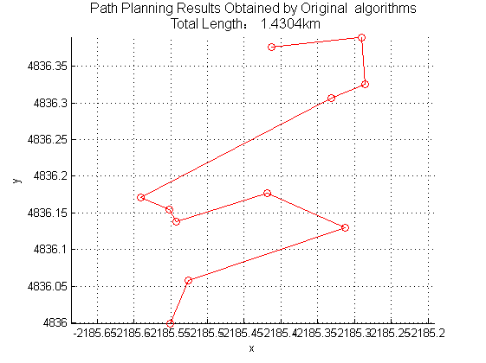
Fig.7. Path Planning Results Obtained by Improve Algorithm

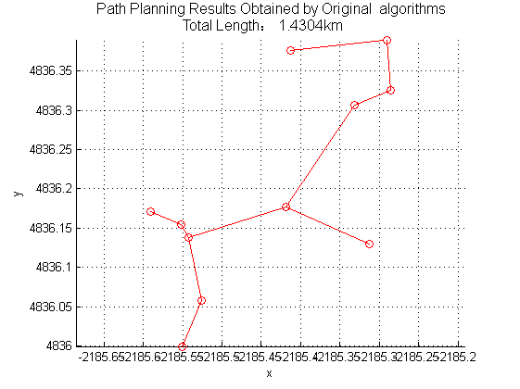
Fig.8. Path Planning Results Obtained by Original Algorithm
- CONCLUSION
In this paper, an improved Prim algorithm is studied by introducing constraint condition to improve the effect of UAV path planning. Simulation result and success application in cruise path planning of UAV show the efficiency of this algorithm.

Table 5 Algorithm Simulation Results

City where points are located | Number of points | Improve algorithm  (km) | original algorithm (km) | Optimal solution  (km) | Improved  Error rate  (%) | Original error rate (%)
Kaifeng | 11 | 1.3250 | 1.4304 | 1.2934 | 2.44 | 10.59
Datong | 12 | 8.0990 | 8.8335 | 8.0990 | 0 | 9.07
Nanjing | 12 | 9.1389 | 9.53994 | 8.8748 | 2.97 | 7.45
Shangqiu | 11 | 6.5667 | 7.9601 | 6.5667 | 0 | 21.22
Shanghai | 8 | 7.4576 | 8.6559 | 7.4576 | 0 | 16.07
Suzhou | 8 | 10.2125 | 12.5889 | 10.0249 | 1.87 | 25.58
Wuxi | 11 | 8.9443 | 9.49764 | 8.9443 | 0 | 6.19
Xian | 13 | 10.8802 | 11.6238 | 10.4092 | 1.1 | 11.67
Zhengzhou | 9 | 5.6563 | 6.1724 | 5.6563 | 0 | 9.12
Chongqing | 9 | 6.3968 | 7.8972 | 6.1072 | 4.74 | 29.31
Table 6 Complex Comparison of Different Algorithm

The algorithm name | time complexity | Average time of algorithm (s) | Error rate of algorithm (%)
Prim algorithm | 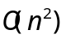 | 1.2694 | 14.627
Improved Prim algorithm |  | 1.3685 | 1.312

REFERENCES
[1] Chu K, Lee M, Sunwoo M. Local Path Planning for Off-Road Autonomous Driving With Avoidance of Static Obstacles[J]. IEEE Transactions on Intelligent Transportation Systems, 2012, 13(4):1599-1616
[2] Jennings A L, Ordonez R, Ceccarelli N. Dynamic programming applied to UAV way point path planning in wind[C]// IEEE International Conference on Computer-Aided Control Systems. 2008:215-220
[3] Mathew M. An Implementation of A Star Search Algorithm for Grid Search[J]
[4] Deb K. A fast elitist multi-objective genetic algorithm: NSGA-II[J]. IEEE Transactions on Evolutionary Computation, 2002, 6(2):182-197
[5] Chang K C, Agate C S. A dynamic path planning algorithm for UAV tracking[J]. Proceedings of SPIE - The International Society for Optical Engineering, 2009, 7336
[6] Yan H, Fan X, Xia X Z. Application of Graph Structure and Dijkstra Algorithm to Track Planning for UAVs[J]. Fire Control & Command Control, 2010
[7] Fu Y, Ding M, Zhou C. Phase Angle-Encoded and Quantum-Behaved Particle Swarm Optimization Applied to Three-Dimensional Route Planning for UAV[J]. IEEE Transactions on Systems Man & Cybernetics Part A Systems & Humans, 2012, 42(2):511-526
[8] Dutta S, Patra D, Shankar H, et al. Development of Gis Tool for the Solution of Minimum Spanning Tree Problem using Prim's Algorithm[J]. International Archives of the Photogrammetry Remote Sensing & S, 2014, XL-8:1105-1114
[9] Nepomnyachchaya A S. Comparison of the Prim-Dijkstra and kraskal algorithms on an associative parallel processor[J]. Cybernetics and Systems Analysis, 2000, 36(2):162-169
[10] Feltens J. Vector method to compute the Cartesian ( X, Y, Z ) to geodetic (, \({\phi\), λ, h ) transformation on a triaxial ellipsoid[J]. Journal of Geodesy, 2009, 83(2):129-137
[11] Du W Y, Jian Z Z, Chen T X. The design of flight control law based on integral separation PID algorithm[C]// International Conference on Electronics and Optoelectronics. IEEE, 2011:V2-442-V2-444
[12] University Z S T, Zhejiang H, Haip C Z S P. Realization of Integral Separation PID Algorithm in Variable Frequency Speed Regulation System[J]. Electrical Automation, 2010
[13] Cordero M, Alarcon F, Jimenez A, et al. Survey on Attitude and Heading Reference Systems for Remotely Piloted Aircraft Systems[C]// International Conference on Unmanned Aircraft Systems. 2014:876-884
[14] Barazzetti A. AIRCRAFT GPS INSTRUMENTATION SYSTEM AND RELATIVE METHOD: US, US 20050143872 A1[P]. 2005
[15] Mariano A, Lee D, Gerstlauer A, et al. Hardware and Software Implementations of Prim's Algorithm for Efficient Minimum Spanning Tree Computation[C]// International Embedded Systems Symposium. 2013:151-158
[16] Zhi-Qin H U. The Realization and Analysis of Prim's Algorithm[J]. Computer Knowledge & Technology, 2011
[17] Pan D Z, Liu Z B, Chen Y J, et al. Realization of the Minimum Cost Spanning Tree’s Storage and Optimization in Prim Algorithm[M]// Applied Informatics and Communication. Springer Berlin Heidelberg, 2011:424-431
[18] Salazar-Cruz S, Palomino A, Lozano R. Trajectory tracking for a four rotor mini-aircraft[C]// Decision and Control, 2005 and 2005 European Control Conference. Cdc-Ecc '05. IEEE Conference on. 2006:2505 – 2510
[19] Bouchoucha M, Tadjine M, Tayebi A, et al. Robust nonlinear PI for attitude stabilization of a four-rotor mini-aircraft: from theory to experiment[J]. Archives of Control Sciences, 2008, 18(1)

 This research was supported in part by the Natural Science Fund of China (Grant No. 61603108 and U1604158) and Technical Innovation Talents Scheme of Henan Province (Grant No. 2012HASTIT005).

